**Master Functional Document**

|  |  |
| --- | --- |
| **Application** | NGERP – Centra |
| **Service Bundle** | Master Management |
| **Service Request** | Customer Support Days |

**Description:**

In Compiere **(NGERP – Centra)**, Customer Support Days tracks discount eligibility and support terms for business partners, including payment deadlines and date ranges.

**Workflow Process:**

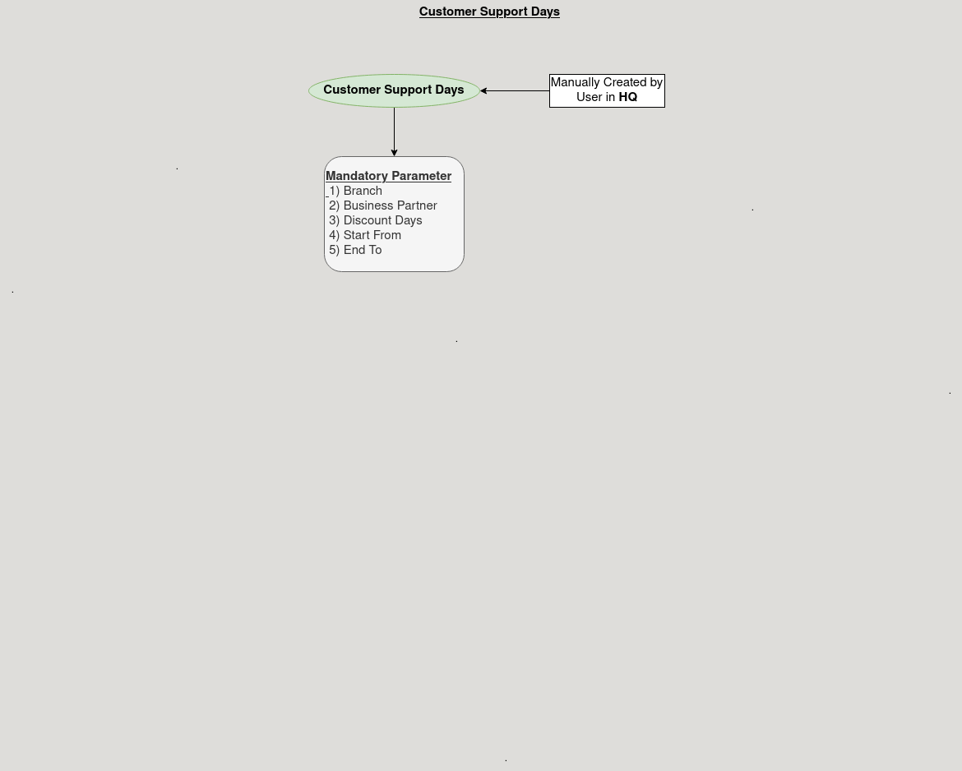

**Business Rules:**

* Customer Support Days is visible in both HQ and ROW for access and reporting.
* Creation of Customer Support Days is only possible at the HQ level.
* Discount Days defines how many days from the invoice date payment must be received to qualify for a discount.
* Records can be deactivated for reporting and audit purposes instead of deleted.
* StartFrom and EndTo must set valid date ranges for discounts or support terms.